Template and Instructions for HFLSM Annual Report (14 pt)

T. Kinken¹, D. Tohoku¹, I. Jiba¹, H. Kyodo² and K. Miyagi² (10 point)
¹ Institute for Materials Research, Tohoku University
² Faculty of Engineering, Kyojiba University

Abstract: The report must have an abstract. The abstract should be self-contained and understandable by a general reader outside the context of the report.

1. Introduction (10 pt, Bold)
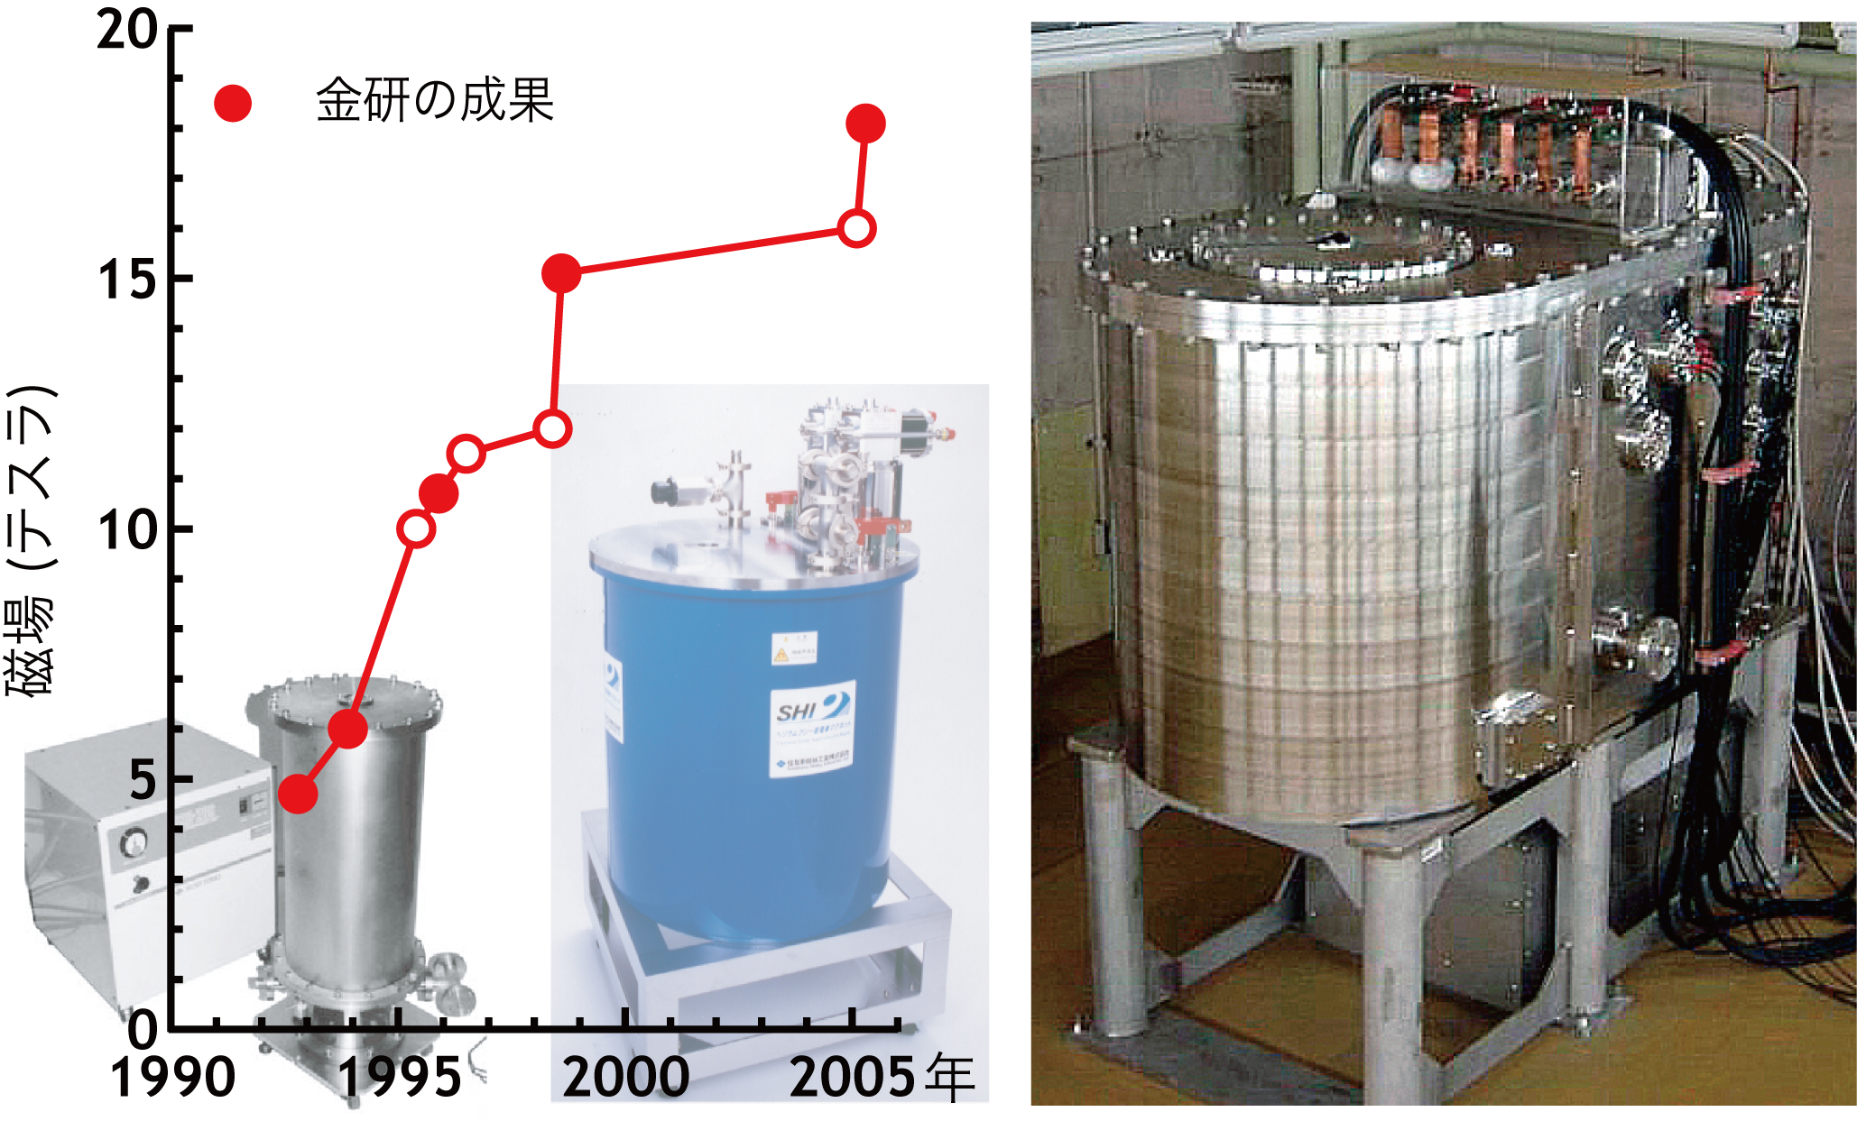

Fig. 1 Progress of practical cryocooled superconducting magnets. Images will be printed in grayscale.
This document is a template and contains instructions for preparing an HFLSM annual report. This template matches the printer settings that will be used in the annual report. A maximum size of 4 pages is required for all reports.
Authors will upload a PDF file of their annual report to the web site[1].

2. Preparing an HFLSM Annual Report
The annual report will be printed in an A4 size. The left, right, top and bottom margins should be 20, 20, 25 and 25 mm, respectively. The document will be printed in black and white.

2-1. Font and Font size
Title of the paper must be typed with a Gothic font, e.g. Helvetica in 14 pt. Author names, affiliations and main text must be typed with Times New Roman in 10 pt. The main text may contain mathematical expressions, graphs, tables and figures, and must be laid out in double columns.

2-2. Figures
Figures must be sufficiently large in order for all details not to become illegible in printed form. Figure captions should be 10 pt size font. Images that remain clear after grayscale printing are required.

2-3. Creating a PDF File
Fonts must be embedded in the PDF file.

3. Uploading a PDF File
Please upload the created PDF file to the web site https://gimrt.appli.imr.tohoku.ac.jp/.

4. Summary
Authors are asked to follow the provided template as close as possible. Use of MS-Word is strongly recommended. Please submit your annual report prior to the deadline. Thank you for your cooperation.

References
[1] URL: https://gimrt.appli.imr.tohoku.ac.jp/.

